6.a)Create a table name student with the following structure

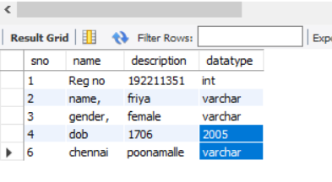

b)create table name faculty with the following structure

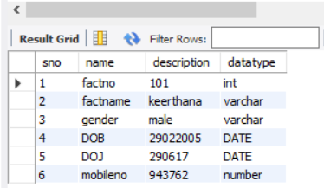

c)create a table name department with the follwing structure

